SQL
Session-4
1.Create a table called Playlist with columns: id, song_name, artist, genre, and play_count. Insert at least 5 sample records representing your favorite songs from Spotify.
CREATE TABLE Playlist(id INT PRIMARY KEY AUTO_INCREMENT,song_name varchar(100),artist varchar(20),genre varchar(50),Play_count INT);
INSERT INTO Playlist (song_name, artist, genre, play_count)
VALUES
('garba', 'Rakesh', 'classic', 150),
('shape', 'Ed Sheeran', 'Pop', 200),
('Honey singh', 'love dosh', 'Rock music', 175),
('Kesariya', 'Arijit Singh', 'Bollywood', 120),
('Tum', 'KK','Romantic', 180);
Output:
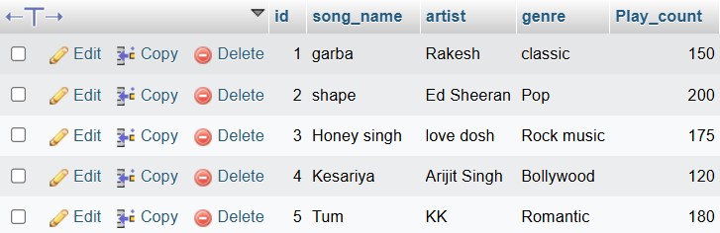

2.Write a SELECT query to display only the song_name and artist from the Playlist table, but show the artist column as 'Singer' using an alias.
SELECT song_name ,artist as Singer
FROM playlist;
Output:
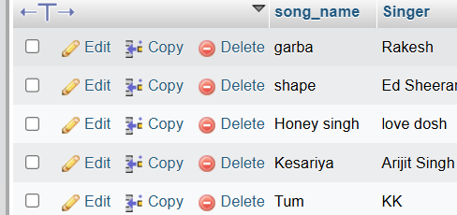

3.Write a SELECT query to find all songs in the Playlist table where the genre is 'Pop' and play_count is greater than 100. Sort the results by play_count in descending order.
SELECT * FROM playlist where genre = 'pop' and Play_count >= 100 ORDER BY Play_count DESC;
Output:
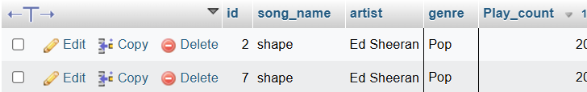

4.Use the COUNT aggregate function to find out how many songs in your Playlist table belong to the genre 'Hip-Hop'.
SELECT COUNT(*) FROM playlist WHERE genre = 'hip hop';
Output:
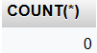

5.Write a SELECT query that shows the total number of plays (SUM of play_count) for each genre in your Playlist table, grouped by genre.<br><br><em><strong>Hint:</strong> Use GROUP BY with the SUM function to aggregate play counts by genre.</em>
SELECT genre, SUM(Play_count) AS total_plays FROM playlist GROUP BY genre;
Output:
